**Title: COSMETIC INSIGHTS : NAVIGATING COSMETIC TRENDS AND CONSUMER INSIGHTS WITH TABLEU**

**MENTOR: K. RATNA KUMARI MADAM**

**TEAM ID : LTVIP2025TMID52569**

**TEAM LEADER : SHAIK KHADAR VALLI BABA**

 **mail id:** [**shaikkhadar0789@gmail.com**](mailto:shaikkhadar0789@gmail.com)

**SBAP0052569**

**TEAM MEMBERS:**

** mail id:** [**muralikrishnavemana073@gmail.com**](mailto:muralikrishnavemana073@gmail.com)

**SBAP0052646**

** mail id :** [**saipraveenmatta@gmail.com**](mailto:saipraveenmatta@gmail.com)

**SBAP0052612**

** mail id :** [**rudrabharath625@gmail.com**](mailto:rudrabharath625@gmail.com)

**SBAP0052561**

** mail id :** [**prasanthkumar78319@gmail.com**](mailto:prasanthkumar78319@gmail.com)

**SBAP0052645**

**Cosmetic Insights : Navigating Cosmetics Trends and Consumer Insights with Tableau**

“Cosmetic Insights : Navigating Cosmetics Trends and Consumer Insights with Tableau" is an innovative project aimed at revolutionizing how cosmetics data is visualized and utilized to drive informed decision-making and enhance brand success in the beauty industry. In today's competitive cosmetics market, having access to comprehensive insights into consumer preferences, product efficacy, and market dynamics is crucial to empower stakeholders with actionable information.

This project seeks to create a dynamic and intuitive platform using Tableau, where data from various aspects of consumer behavior, product performance, and market trends can be transformed into interactive visualizations and insightful analytics. By leveraging Tableau's capabilities effectively, the "Cosmetic Insights" project aims to empower cosmetics companies with actionable insights, foster data-driven decision-making, and drive business growth by facilitating a deeper understanding of consumer dynamics and promoting evidence-based marketing strategies.

Scenarios:

Scenario 1: Monitoring Consumer Preferences

In a real-time scenario, imagine receiving an alert indicating a concerning trend in consumer preferences, such as a significant decline in interest in certain cosmetic products or ingredients. Using the Cosmetic Insights data, we can promptly assess the extent and potential impact of this trend, identify contributing factors, and deploy immediate interventions to adapt product offerings and marketing strategies. Whether it’s through targeted promotional campaigns, adjustments in product formulations, or personalized recommendations, real-time analysis enables agile decision-making and proactive measures to meet evolving consumer needs.

Scenario 2: Addressing Product Concerns

In the event of identifying widespread product concerns, such as negative reviews or safety issues associated with specific cosmetic items, real-time access to Cosmetic Insights data enables swift response and management. Cosmetic companies and regulatory bodies can utilize the dataset to gather crucial information about the concerns, including their prevalence, potential impacts on consumer trust, and affected product demographics. By leveraging real-time analytics, they can implement quality control measures, recall products if necessary, and communicate transparently with consumers to address their concerns and maintain brand integrity.

Scenario 3:  Predictive Analysis and Product Innovation

Leveraging predictive analytics capabilities, Cosmetic Insights empowers companies to anticipate and respond to emerging trends and consumer preferences in the beauty industry. By analyzing historical data and identifying predictive indicators, companies can proactively innovate new products, adjust existing formulations, and tailor marketing strategies to meet evolving consumer demands. Real-time monitoring of market trends, consumer feedback, and competitor activities enables timely interventions, product innovation, and strategic decision-making to stay ahead in a competitive market landscape.

**Technical Architecture**

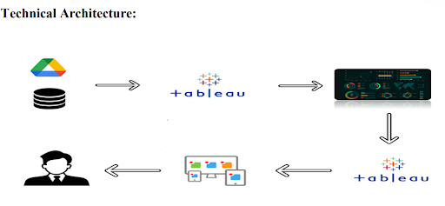

**Project Flow**

To accomplish this, we have to complete all the activities listed below,

? Data Collection & Extraction from Database

o Collect the dataset,

o Connect data with Tableau

? Data Preparation

o Prepare the Data for Visualization

? Data Visualizations

o No of Unique Visualizations

? Dashboard

o Responsive and Design of Dashboard

? Story

o No of Scenes of Story

? Performance Testing   
o Amount of Data Loaded

o Utilization of Data Filters

o No of Calculation Fields

o No of Visualizations/ Graphs

? Web Integration

o Dashboard and Story embed with UI With Flask

? Project Demonstration & Documentation

o Record explanation Video for project end to end solution

o Project Documentation-Step by step project development procedure

**Data Collection & Extraction from Database**

Data collection is the process of gathering and measuring information on variables of interest, in an established systematic fashion that enables one to answer stated research questions, test hypotheses, evaluate outcomes and generate insights from the data.

**Downloading the dataset**

Activity 1.1: Understand the data

Data contains all the meta information regarding the columns described in the CSV files

Column Description of the Dataset:

1. Label:  Type of Product
2. Brand: Brand of Product
3. Name: Name of Cosmetic
4. Price: Price in USD
5. Rank: Ranking
6. Ingredients: Ingredients
7. Combination: Combination of Dry and Oily
8. Dry: For Dry Skin
9. Normal: For Normal Skin
10. Oily: For Oily Skin
11. Sensitie: For Sensitive Skin
12. 
13. Cosmetics datasets | Kaggle..
14. Cosmetics ingredients, rank, price and effects on skin..
15. <https://www.kaggle.com/datasets/kingabzpro/cosmetics-datasets>

**Loading the Dataset**

Dataset file is CSV format  
Steps:  
Open Tableau Desktop

* Launch the Tableau application on your computer.

Connect to a Data Source

* On the home screen, under “Connect”, choose:
* “Text File” (This is used for CSV files).

Browse and Select Your CSV

* A file dialog will open.
* Navigate to the location of your .csv file.
* Select it and click “Open”.

View Data in Data Source Tab

* Tableau loads your CSV file into the Data Source tab.
* You can preview and clean data here (rename columns, change data types, split fields, etc.).

Drag to Canvas (if needed)

* If your CSV has multiple files (rare), drag the desired sheet to the canvas area.

Go to Worksheet

* Click on “Sheet 1” at the bottom to start building visualizations using the uploaded CSV data.

**Data Preparation**

* **Prepare the Data for Visualization**

Preparing the data for visualization involves cleaning the data to remove irrelevant or missing data, transforming the data into a format that can be easily visualized, exploring the data to identify patterns and trends, filtering the data to focus on specific subsets of data, preparing the data for visualization software, and ensuring the data is accurate and complete. This process helps to make the data easily understandable and ready for creating visualizations to gain insights into the performance and efficiency. Since the data is already cleaned, we can move to visualization.

**Data Visualization**

Data visualization is the process of creating graphical representations of data to help people understand and explore the information. The goal of data visualization is to make complex data sets more accessible, intuitive, and easier to interpret. By using visual elements such as charts, graphs, and maps, data visualizations can help people quickly identify patterns, trends, and outliers in the data.

**visualizations**

Link: <https://drive.google.com/file/d/1Gew9TcVNBWdIT8n5Zhk1-mV8xpRa5E5_/view?usp=drive_link>

Activity 1.1: Top Brands:

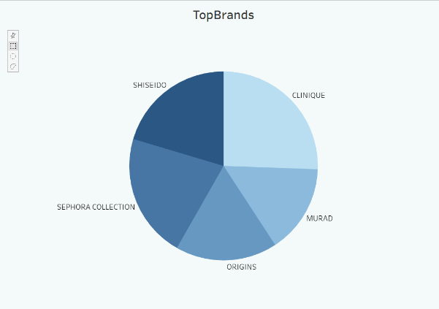

 Activity 1.2: Label Count

Explanation Link: [CosmeticsLabels.mp4](https://drive.google.com/file/d/1Gew9TcVNBWdIT8n5Zhk1-mV8xpRa5E5_/view?usp=sharing)

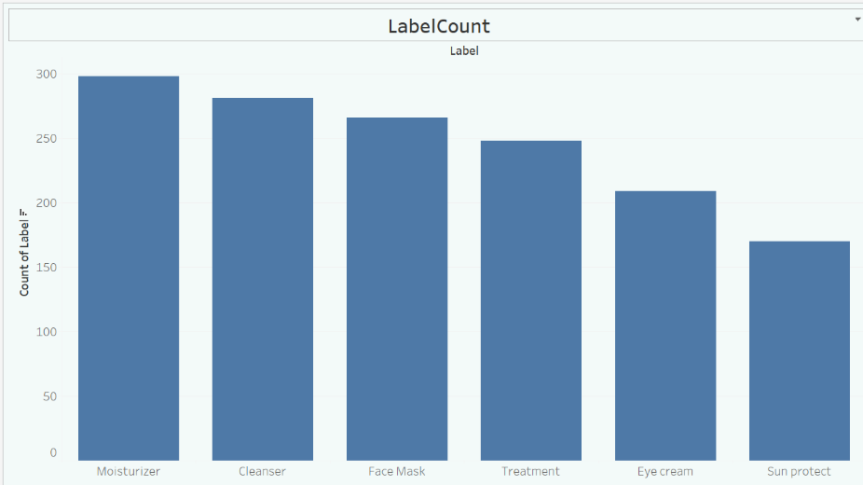

Activity 1.3: Price  vs Brand

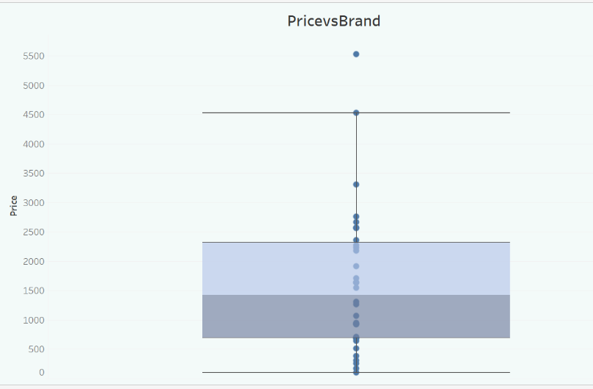

Activity 1.4 : Sensitive Skin Suitability

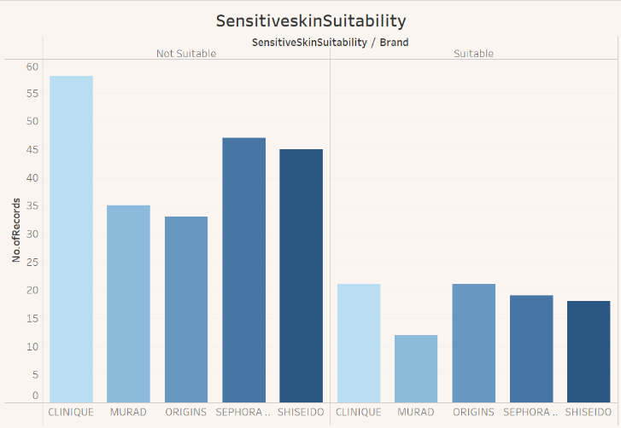

Activity 1.5 : Dry Skin Suitability

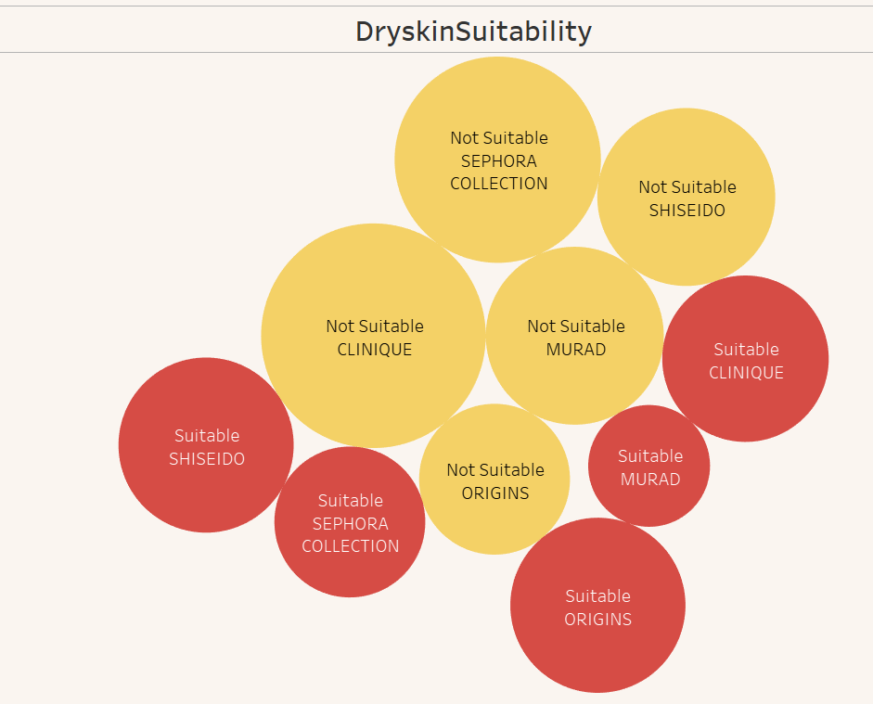

Activity 1.6 : Normal Skin Suitability

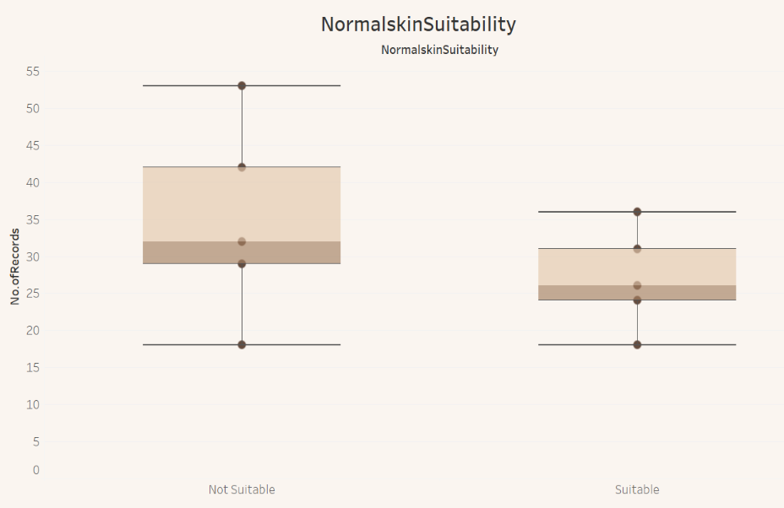

Activity 1.7 : Oily skin suitability

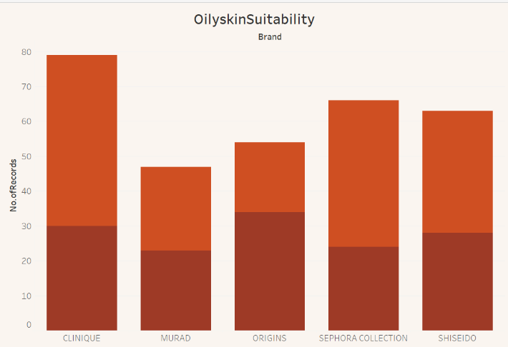

Activity 1.8 : Brand vs Ranking

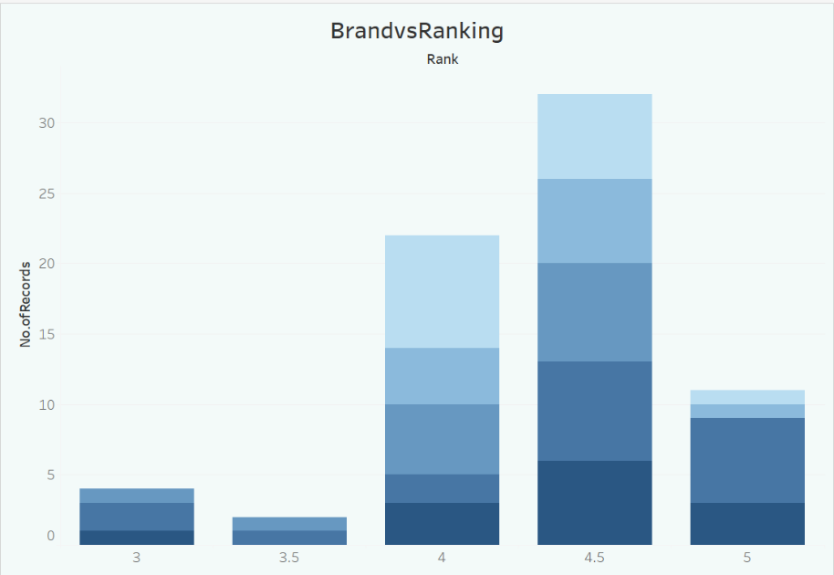

Activity 1.9 : Label vs Ranking

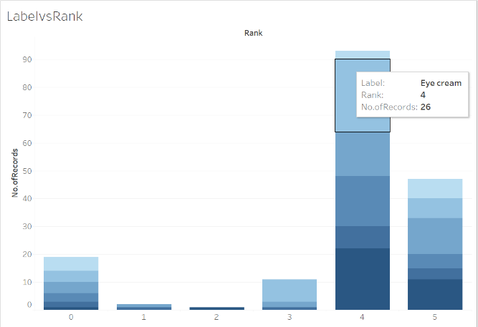

**Dashboard**

A dashboard is a graphical user interface (GUI) that displays information and data in an organized, easy-to-read format. Dashboards are often used to provide real-time monitoring and analysis of data and are typically designed for a specific purpose or use case. Dashboards can be used in a variety of settings, such as business, finance, manufacturing, healthcare, and many other industries. They can be used to track key performance indicators (KPIs), monitor performance metrics, and display data in the form of charts, graphs, and tables.

**Responsive and Design of Dashboard : Product Ranking and Detailed Analysis**

Dashboard 1:

Cosmeticsdashboard1.mp4 - Google Drive..

No description..

<https://drive.google.com/file/d/1x63UzlNd-84V6gZ4DhA79jm7ISlIyg10/view?usp=sharing>

**Product Suitability Overview**

Dashboard 2:

CosmeticsDashboard2.mp4 - Google Drive..

No description..

<https://drive.google.com/file/d/1bkT7dATbR-RJl8byCBss26avBU0qPzyM/view?usp=sharing>

**Story**

A data story is a way of presenting data and analysis in a narrative format, with the goal of making the information more engaging and easier to understand. A data story typically includes a clear introduction that sets the stage and explains the context for the data, a body that presents the data and analysis in a logical and systematic way, and a conclusion that summarizes the key findings and highlights their implications. Data stories can be told using a variety of mediums, such as reports, presentations, interactive visualizations, and videos.

**No of Scenes of Story**

**Performance Testing**

Amount of Data Loaded

"Amount of Data Loaded" refers to the quantity or volume of data that has been imported, retrieved, or loaded into a system, software application, database, or any other data storage or processing environment. It's a measure of how much data has been successfully processed and made available for analysis, manipulation, or use within the system.

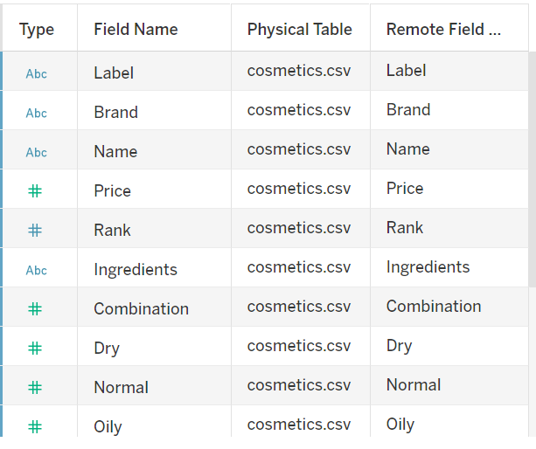



**No of Visualizations/ Graphs**

* Top Brands
* Label Count
* Price vs Brand
* Sensitive skin suitability
* Normal skin suitability
* Oily skin suitability
* Dry skin suitability
* Brand vs Ranking
* Label vs Ranking

**Web integration**

Publishing helps us to track and monitor key performance metrics, to communicate results and progress. help a publisher stay informed, make better decisions, and communicate their performance to others. Publishing dashboard and reports to tableau public

**Go to Dashboard/story, click on share button on the top ribbon**

Give the server address of your tableau public account and click on connect.

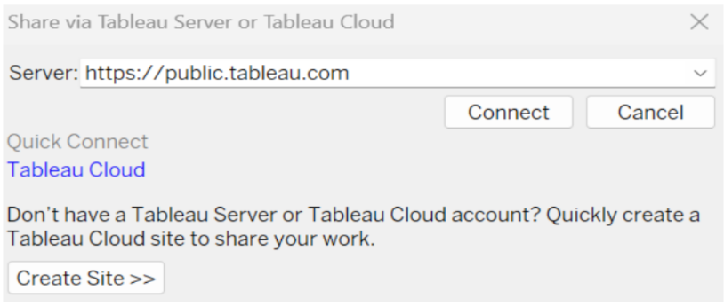

Step 2: Once you click on connect it will ask you for tableau public user name and password.

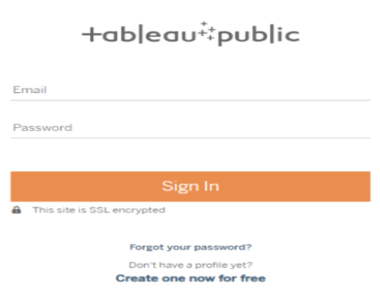

Once you login into your tableau public using the credentials, the particular visualization will be published into tableau public.

Note: While publishing the visualization to the public, the respective sheet will get published when you click on share option

<https://drive.google.com/file/d/19n5bhOdDt-cDrJMO_r9EWmxzc-6G3mn4/view?usp=sharing>

**Dashboard and Story embed with UI With Flask**



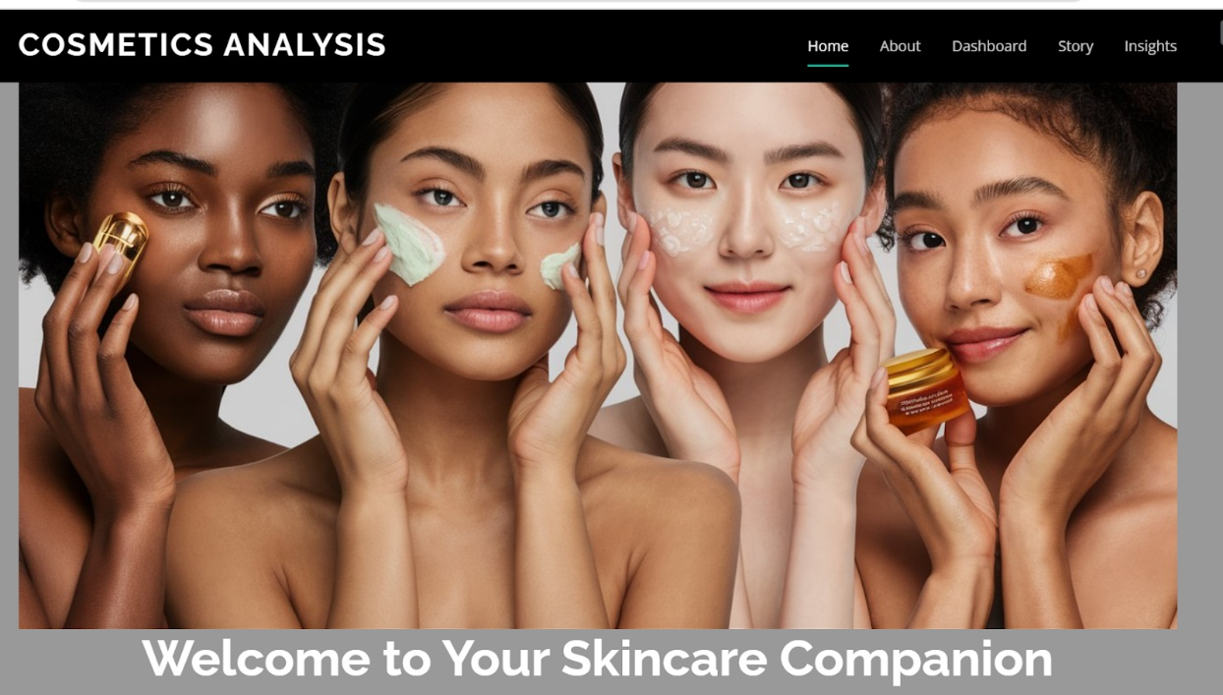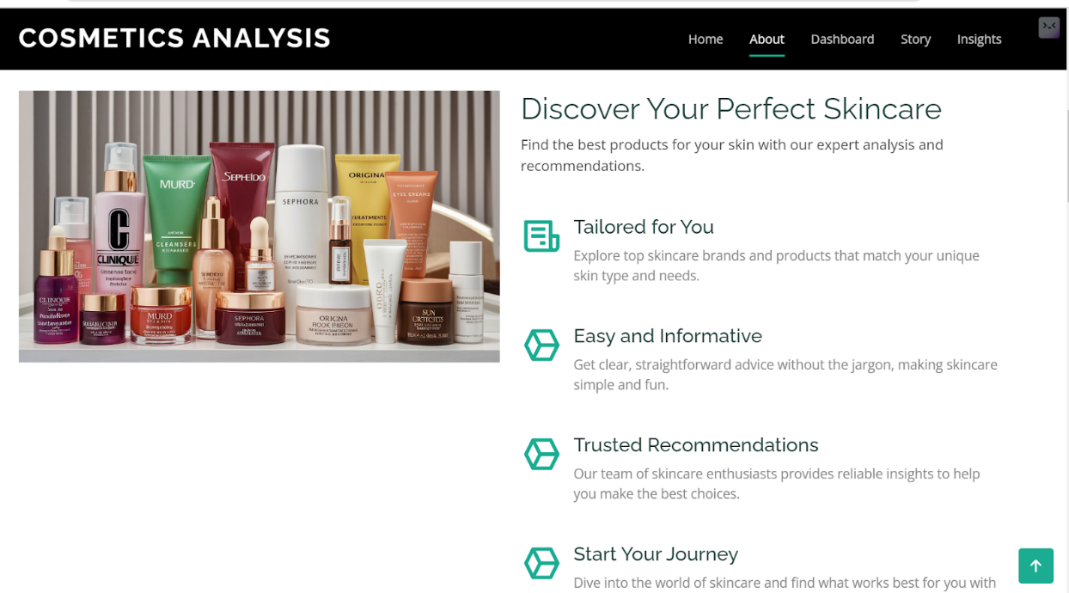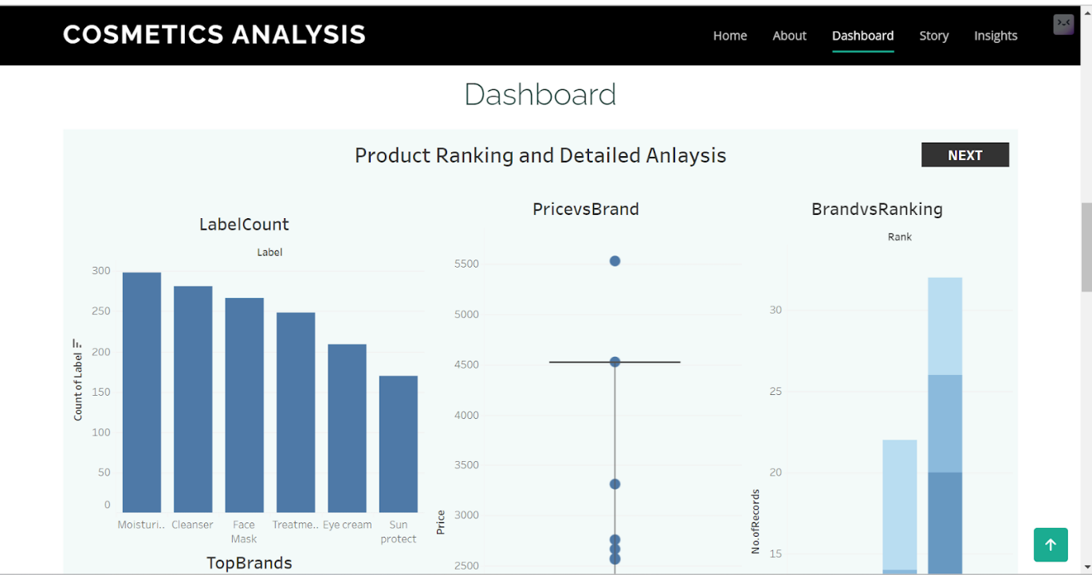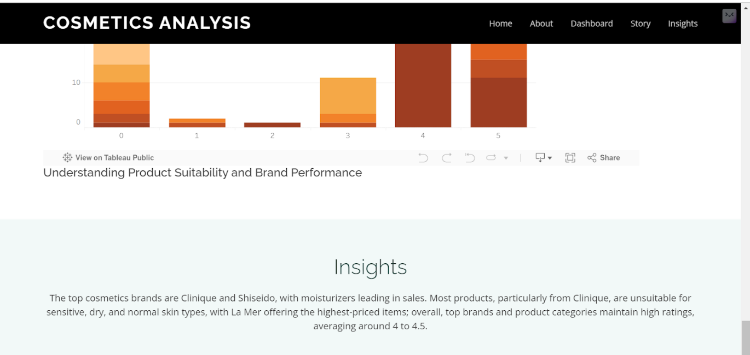

<https://drive.google.com/file/d/19zuSK6Kn8iYzdzDrGTtrHwX6v41bGqa3/view?usp=sharing>